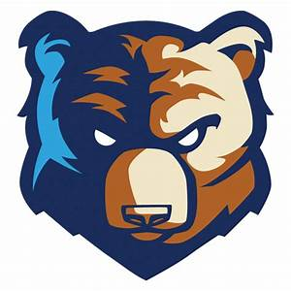
Bob Jones Bruins Basketball
2021-2022 Player Review
Player:
Class:
Position:
Coach:

Strengths of Your Game | *circle 1-2 in each column
Offense | Defense | Transition
Attacking the Rim off the Dribble | Defensive Communication | Making the Outlet Pass
Finishing at the Rim | Containing the Ball | Getting to the “Outlet Box”
Post Scoring | One Pass Away Denial | “BYOO” Be Your Own Outlet
Jump Shooting | “Getting Touches” Deflections/Steals | Effort in Sprinting the Sideline
3 Point Shooting | Post Up Defense | Effort in Rim Running
Free Throw Shooting | Help Side Defense | Making the Pitch Ahead Pass
Shot Selection | Physicality / Boxing Out | Crossing the Rimline When Denied
Assist to Turnover Ratio | Defensive Rebounding | Trailers arrive in the Slots
Passing | Ball Screen & Roll Defense | Decision-Making with the Basketball
Ball Handling | Off the Ball Screening Defense | Finishing at the Basket in Transition
Setting Screens & Reading Screens | Full Court Press Defense | Weak Hand Finishes & Attacks
Offensive Rebounding | Anticipating the Next Pass | Understanding of Spacing

Room for Improvement | *circle 1-2 in each column
Offense | Defense | Transition
Attacking the Rim off the Dribble | Defensive Communication | Making the Outlet Pass
Finishing at the Rim | Containing the Ball | Getting to the “Outlet Box”
Post Scoring | One Pass Away Denial | “BYOO” Be Your Own Outlet
Jump Shooting | “Getting Touches” Deflections/Steals | Effort in Sprinting the Sideline
3 Point Shooting | Post Up Defense | Effort in Rim Running
Free Throw Shooting | Help Side Defense | Making the Pitch Ahead Pass
Shot Selection | Physicality / Boxing Out | Crossing the Rimline When Denied
Assist to Turnover Ratio | Defensive Rebounding | Trailers arrive in the Slots
Passing | Ball Screen & Roll Defense | Decision-Making with the Basketball
Ball Handling | Off the Ball Screening Defense | Finishing at the Basket in Transition
Setting Screens & Reading Screens | Full Court Press Defense | Weak Hand Finishes & Attacks
Offensive Rebounding | Anticipating the Next Pass | Understanding of Spacing

Player Notes:
Performance this Season:

Effort, Attitude, & Leadership Skills:

Skills to Work on:

Personal Goals/Expectations for Next Season:

Offseason Plan:

