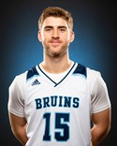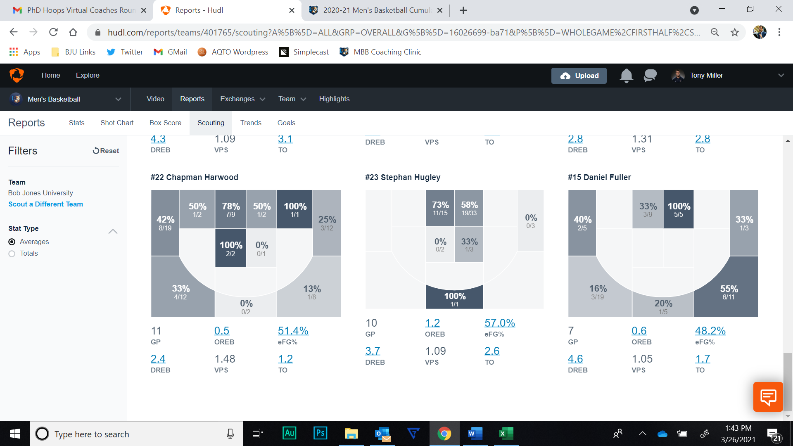

**DEVELOPMENTAL GOALS**

1. Improve lateral quickness and linear speed
2. Improve ball handling
3. Shooting off the move
4. Finishing through contact around the basket
5. Improve on seeing the whole court and making the “one more” pass

**Skill Specific Drills**

Season: 2020-2021

**WEAKNESSES**

* Off ball defense – zone defense / awareness
* Staying in front of the ball handler
* Basketball IQ – watching film / foreseeing basketball plays

**DANIEL FULLER**

**#33**

Classification: Junior

Position: Wing

Height: 6’5”

Weight: 202

FG%: 37% | 3PT%: 30% | FT%: 64%

MPG: 23.1 | PPG: 8.9 | RPG: 5.3

**STRENGTHS**

* Catch and shoot 3P
* Coachable
* Respected by teammates

**2-YEAR PROJECTION**

* Team Captain
* Key contributor offensively and defensively

**COMBINE TESTING**

% Body Fat: --

Standing Reach: 8” (-1)

Wingspan: 6’2” (+.75)

Standing Jump: 10’2” (-1)

Max Jump: 10’8”

Bench: 250 (+5)

Squat: --

Clean: --

185 Bench Reps: 15 (+7)

Lane Agility: --  
¾ Court Time: --

**PHYSICAL MAKEUP**

* Above average strength
* Improved explosiveness and vertical leap
* Target weight 195-200 (drop in body fat, not muscle)

**MENTAL MAKEUP**

* Coachable and a desire to improve
* Continue to develop a “Next Play” mentality

**PLAYER OVERVIEW**

* Played in 7 games (torn ACL)
* South Region All-Freshman Team